# Lab Week 11: Reinforcement Learning

The lab this week covers reinforcement learning (RL). Whilst this content will *not* be covered in Coursework 2, it is still relevant for your journey in AI.

There are two tasks, and you can choose either to work on. The first, makes use of TensorFlow/Keras as our ML libraries, whereas in the 2nd, you will be exposed to PyTorch, the “other” main library for Deep Learning.

# Task 1: Reinforcement Learning with TensorFlow / Keras

In the first task you will work through tutorials by the TensorFlow/Keras authors to show you example RL applications.

Specifically read & work through the following:

* [TensorFlow Introduction to RL](https://www.tensorflow.org/agents/tutorials/0_intro_rl)
* [Train a Deep Q Network with TensorFlow](https://www.tensorflow.org/agents/tutorials/1_dqn_tutorial)
* [Actor-Critic RL on the CartPole](https://keras.io/examples/rl/actor_critic_cartpole/)
* [Deep Q Learning on Atari](https://keras.io/examples/rl/deep_q_network_breakout/)

In all those linked Notebooks, you could use your local version (Jupyter Notebook or Visual Studio Code). However, it may be beneficial to use the options on those resources, to use Google Colab, as you have more powerful hardware attached to it.

# Task 2: Making Decisions in Complex Environments with Reinforcement Learning

For task 2 you will use of the book: **Python Machine Learning by Example, Liu, Y., (2020),** by Packt Publishing.

You can access the digital version of this book by going to the module’s sidebar, clicking on Resource-Lists and then you should be able to see the E-Book version.

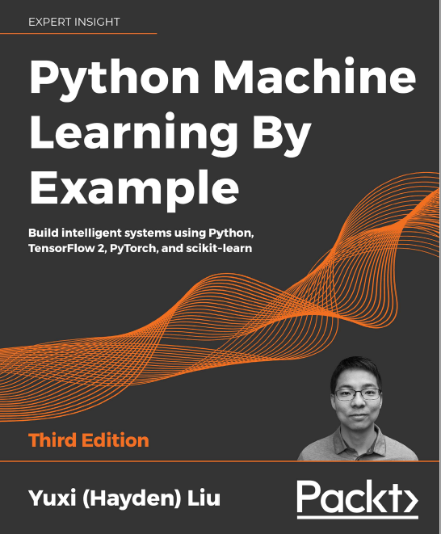

Figure Python Machine Learning by Example: Book

You should then open the book in a new window or tab, as you will be referring back to this.

In this task, you should work through **Chapter 14: *Making Decisions in Complex Environments with Reinforcement Learning*** of this book.

This task will give you a good overview over Reinforcement Learning and ***also expose you to another Python library for deep learning,* PyTorch.**

**Please NOTE: For this task you will need to install PyTorch and the “gym” library into your Anacond environment:**

conda install pytorch torchvision -c pytorch

pip install gym